1. Print the total price of orders which have the the products supplied by ‘Exotic Liquids’ if the price is >50 and also it by shipping company’s name.

CREATE TABLE Orders2

(

OrderID int,

Supplier_Name varchar(20),

Product_Name Varchar(20),

Product_Price int,

Company_Name varchar(20),

DO_Order date,

);

select * from Orders2;

insert into Orders2(OrderID,Supplier_Name,Product_Name,Product_Price,Company_Name,DO_Order)

values(101,'Exotic Liquids','Hand wash',500,'Savlon','2022-02-02');

insert into Orders2(OrderID,Supplier_Name,Product_Name,Product_Price,Company_Name,DO_Order)

values(102,'Exotic Liquids','Hand wash',500,'Savlon','2022-04-02');

insert into Orders2(OrderID,Supplier_Name,Product_Name,Product_Price,Company_Name,DO_Order)

values(103,'Exotic Liquids','Perfume',200,'Savlon','2022-06-02');

insert into Orders2(OrderID,Supplier_Name,Product_Name,Product_Price,Company_Name,DO_Order)

values(104,'Exotic Liquids','Handwash',500,'Savlon','2022-03-02');

insert into Orders2(OrderID,Supplier_Name,Product_Name,Product_Price,Company_Name,DO_Order)

values(105,'Herbal Liquids','Perfume',500,'Savlon','2022-05-02');

insert into Orders2(OrderID,Supplier_Name,Product_Name,Product_Price,Company_Name,DO_Order)

values(106,'Herbal Liquids','Perfume',300,'capgemini pvt LTD','2022-05-02');

select ProductName.Supplier_Name,ProductName[Unit-price] AS totalprice,Ship.[CompanyName]From productName

inner join companyName on company[companyName]=Product_Name.[CompanyName];

Where proudctName.suppliers_name='exotic Liquid' AND product_name.[UNIT-PRICE]>50

2.Display the employee details whose joined first

select * from EMP1 order by DOJ;

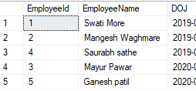

3. Display the employee details whose joined at recently.

select * from EMP1 order by DOJ DESC;

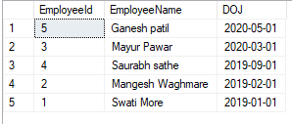

4.write a query to get most expense and least expensive product list.

SELECT Product_Name,Product_Price

from Orders2

order by Product_Price DESC;

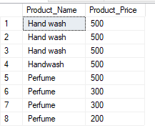

5.Display the list of products that are out of stock.

select Product_Name, UnitsInstock, UnitonOrder

from Orders2

where( (Discontinued)=False)AND( (UnitInStock)<UnitonOrder);

6.Display the list of products whose unitinstock is less than unitonorder.

7.Display the List of categories and suppliers who supply products within those categories.

SELECT OrderID, Product_Name

FROM Orders2

ORDER BY Product_Name;

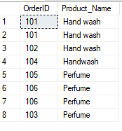

8..Display complete list of customers, the OrderId and date of any orders they have made orders.

select * from Orders2 ORDER BY DO_Order;

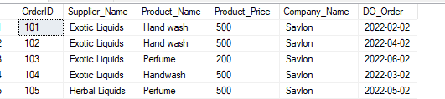

9. write query that determines the customer who has placed the maximum number of orders.

select * from orders2 o, customer c where o.cusId = c.cusId and o.cusId IN

(select cusId from orders group by cusId having count(*) = (select count(*) from orders

or group by or.cusId order by count(*) desc limit 1));

10.Display the customers whose name has substring ‘RA’

select * from Customer1 where c_Name like'Ra%';

C:\Users\Shital\Pictures\Screenshots\Screenshot (373).png

11.Display the first word of all the company name.

select SUBSTRING_INDEX(Company_Name, '', 1) as MyResult From Orders2;